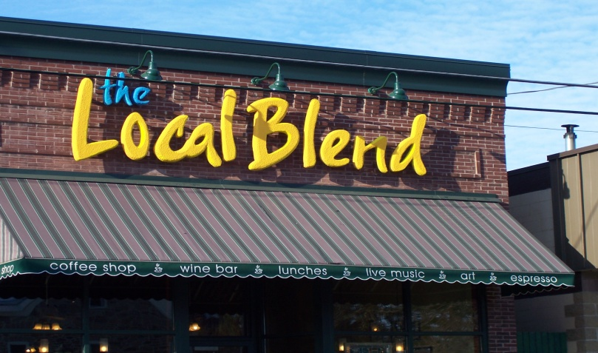

- Loan funds may be used for acquisition of land and/or buildings(s), rehabilitation of building(s), reconstruction, new construction, site improvements, utilities or infrastructure, and purchase of industrial equipment in connection with starting a new business or expanding an existing business.

- Land and building must be privately owned, taxable property and proposed for commercial and/or industrial activities.

- If building(s) are being purchased or rehabilitated with funds from the Revolving Loan Fund any/all building code violations must be remedied. The project must comply with the St. Joseph City Code including standards relating to land use.

- Revolving loan fund assistance can be for no more than one-half of the cost of the project for projects in excess of $50,000 in value. Projects estimated at $50,000 or less may be exempted from this standard at the sole discretion of the EDA.

- Ineligible activities include the operation or expansion of a casino, sports facility when the principal tenant is a professional sports team, housing projects and operating expenses.

Applications available at www.cityofstjoseph.com
320-363-7201
thaffner@cityofstjoseph.com
Eligible Loan Activities

St. Joseph EDA Revolving Loan
The St. Joseph Economic Development Authority’s (EDA’s) Revolving Loan Program has been established to stimulate St. Joseph’s economy by providing low interest secured loans to small and medium sized businesses.

Revolving loan funds can be used for business start-ups, expansion, and retentions where jobs are created or retained. Eligible applicants include most industrial businesses, commercial businesses and technological service businesses.

Application Process
Applicant meets with St. Joseph EDA staff to discuss proposed project and loan program guidelines. If project meets program objectives, applicant submits:

- Statement describing business and proposed plans;

- Project description – purpose of loan and expected benefits. Itemize and provide cost estimate for building improvements and/or equipment;

- Sources/Uses proforma for the project;

- Complied profit and loss statement for the past two (2) years (if applicable);

- Personal financial statement(s) (for use in connection with applicant’s equity requirement);

- Other pertinent data

A sub-committee reviews the application to determine whether or not it is complete. If the application is determined to be complete, the subcommittee formulates a recommendation to the full EDA.

The St. Joseph EDA reviews the application and makes a recommendation to the City Council. Upon approval, a Development Agreement and all other necessary documents in connection with the loan are prepared and executed.

PLACE PHOTO HERE,
OTHERWISE DELETE BOX

Revolving Loan Fund (RLF)

